Rubric for Academic Conversation Skills - LA example
 | Meeting or exceeding expectations | Approaching expectations | Below expectations
Thinking and Talking like Experts | Interprets themes & applies to life; Connects to characters & other texts; Critiques texts and author’s techniques; Uses with ease appropriate literature terms & academic expressions | Provide some interpretations and applications to life; Uses some literature terms & academic expressions; Shows some deep thinking. | Remains at retell level;  Gives few or no interpretation; Fails to extend conversation;  Avoids or uses minimal literature terms & academic expressions
Building On &/ Challenging Ideas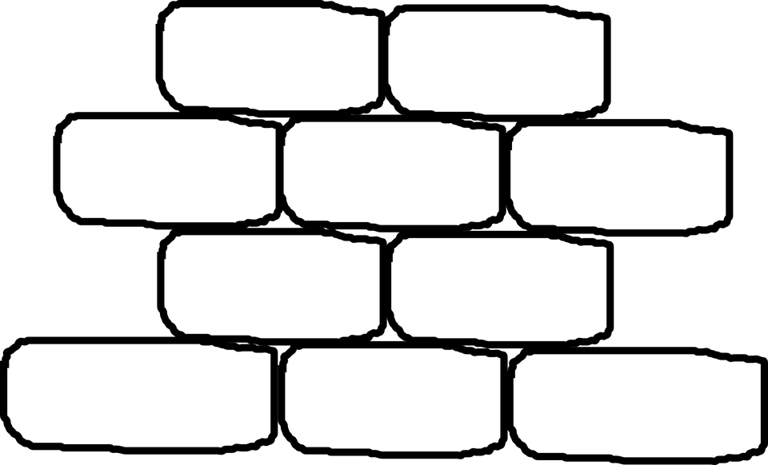 | Generates logical theme(s); Stays on topic; Builds on one another’s comments. | Mostly stays on topic with a few tangents; Demonstrates some building of an idea. | Rarely connects or builds on ideas; Uses disconnected, random ideas; Goes off on many tangents.
Supporting Ideas | Supports ideas and opinions with examples from text, life, and/or previous discussions; Clearly explains and elaborates on ideas. | Provides some support of ideas with examples and/or clarifications; Uses some prompts to encourage support. | Provides little or no support of ideas and themes; Fails to use appropriate prompting.
Paraphrasing | Paraphrases partner ideas to clarify, deepen, and stay focused; Synthesizes key points. | Offers some paraphrasing and synthesizing of key ideas. | Offers little or no paraphrasing and synthesizing.
Communication  Behaviors | Actively listens, take turns, values and respects partner comments. | Uses some appropriate listening and turn-taking behaviors. | Fails to focus on partner; interrupts; Dominates conversation or does not contribute at all.
Adapted by J. Russell Valezy @teachells, AISB, Budapest 2017, Based on Zwiers, J. and Crawford, M. (2011) Academic Conversations: Classroom Talk that Fosters Critical Thinking and Content Understandings. Portland: Stenhouse.

Rubric for Academic Conversation Skills - Science example
 | Meeting or exceeding expectations | Approaching expectations | Below expectations
Thinking and Talking like Experts | Makes a claim supported by strong evidence collected and clear reasoning as to how genetics and/or environment affect the growth of a tree.  Uses with ease appropriate scientific vocabulary & academic expressions to present and argue the claim. | Attempts to make a claim with some evidence collected and provides somewhat clear reasoning as to how genetics and/or environment affect the growth of a tree.  Uses some scientific vocabulary & academic expressions to present and/or argue the claim. | Unsure of a claim, and/or minimal evidence collected, and/or minimal or unclear reasoning as to how genetics and/or environment affect the growth of a tree.  Avoids or uses minimal scientific vocabulary & academic expressions to present and/or argue the claim.
Building On &/ Challenging Ideas | Generates logical theme(s); Stays on topic; Builds on one another’s comments. | Mostly stays on topic with a few tangents; Demonstrates some building of an idea. | Rarely connects or builds on ideas; Uses disconnected, random ideas; Goes off on many tangents.
Supporting Ideas | Supports ideas and opinions with examples from text, life, and/or previous discussions; Clearly explains and elaborates on ideas. | Provides some support of ideas with examples and/or clarifications; Uses some prompts to encourage support. | Provides little or no support of ideas and themes; Fails to use appropriate prompting.
Paraphrasing | Paraphrases partner ideas to clarify, deepen, and stay focused; Synthesizes key points. | Offers some paraphrasing and synthesizing of key ideas. | Offers little or no paraphrasing and synthesizing.
Communication  Behaviors | Actively listens, take turns, values and respects partner comments. | Uses some appropriate listening and turn-taking behaviors. | Fails to focus on partner; interrupts; Dominates conversation or does not contribute at all.
Adapted by J. Russell Valezy @teachells, AISB, Budapest 2017, Based on Zwiers, J. and Crawford, M. (2011) Academic Conversations: Classroom Talk that Fosters Critical Thinking and Content Understandings. Portland: Stenhouse.

Rubric for Academic Conversation Skills - Generic content template
 | Meeting or exceeding expectations | Approaching expectations | Below expectations
Thinking and Talking like Experts | (insert relevant learning standards/benchmarks being assessed)  Uses with ease appropriate content-related terms & academic expressions | (insert relevant learning standards/benchmarks being assessed)  Uses some content-related terms & academic expressions | (insert relevant learning standards/benchmarks being assessed)  Avoids or uses minimal content-related terms & academic expressions
Building On &/ Challenging Ideas | Generates logical theme(s); Stays on topic; Builds on one another’s comments. | Mostly stays on topic with a few tangents; Demonstrates some building of an idea. | Rarely connects or builds on ideas; Uses disconnected, random ideas; Goes off on many tangents.
Supporting Ideas | Supports ideas and opinions with examples from text, life, and/or previous discussions; Clearly explains and elaborates on ideas. | Provides some support of ideas with examples and/or clarifications; Uses some prompts to encourage support. | Provides little or no support of ideas and themes; Fails to use appropriate prompting.
Paraphrasing | Paraphrases partner ideas to clarify, deepen, and stay focused; Synthesizes key points. | Offers some paraphrasing and synthesizing of key ideas. | Offers little or no paraphrasing and synthesizing.
Communication  Behaviors | Actively listens, take turns, values and respects partner comments. | Uses some appropriate listening and turn-taking behaviors. | Fails to focus on partner; interrupts; Dominates conversation or does not contribute at all.
Adapted by J. Russell Valezy @teachells, AISB, Budapest 2017, Based on Zwiers, J. and Crawford, M. (2011) Academic Conversations: Classroom Talk that Fosters Critical Thinking and Content Understandings. Portland: Stenhouse.

